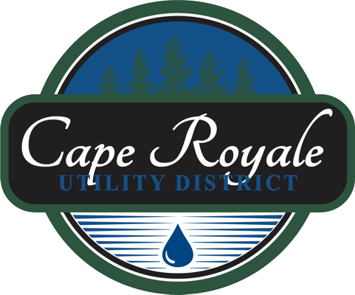
Forms are Under Construction
We are working quickly to update the forms to be more Informative.

We Apologize for any inconvenience Please contact the Office for any questions we are open Monday Through Friday 7:30am-4:00pm

